**Unit I**

**Introduction:**

Meaning, scope, Significance, Objectives, Function of HR department, Personal Policies, Programs and Procedures

**Manpower Management:**

Need and Objectives of Manpower Planning, Estimating Manpower

requirements, Job Analysis, Job Description & Job Specification.

**OUTCOMES:**

After studying this unit, students will gain a comprehensive understanding of HRM principles, enabling them to effectively manage personnel, plan workforce needs, conduct job analyses, and develop essential HR policies, contributing to their readiness for managerial roles in diverse organizations.

**HUMAN RESOURCE:**

* Human resources (HR) is the division of a business that is charged with finding, recruiting, screening, and training job applicants.
* It also administers employee benefit programs.
* Human Resources (HR) focuses on managing an organization’s most valuable asset: its employees.
* It refers to the people who work for a company or organization. It's about managing and optimizing the contributions of individuals to help the organization achieve its goals and success.

**Human:** refers to the skilled workforce in an organization.

**Resource:** refers to limited availability or scarce.

**Management:** refers how to optimize and make best use of such limited or scarce resource so as to meet the organization goals and objectives.

**MEANING OF HRM (Human Resource Management):-**

* Human Resource Management is the process of recruiting, selecting, inducting employees, providing orientation, imparting training and development, appraising the performance of employees, deciding compensation and providing benefits, motivating employees, maintaining proper relations with employees and their trade unions, ensuring employees safety, welfare and healthy measures in compliance with labour laws of the land and finally following the Orders / Judgements of the concern High Court and Supreme Court, if any.
* Human resource management (HRM) is the practice of recruiting, hiring, deploying and managing an organization's employees.
* Human resource management is organising, coordinating, and managing employees within an organisation to accomplish its mission, vision, and goals.
* This includes recruiting, hiring, training, compensating, retaining, and motivating employees.
* Human Resource Management involves management functions like planning, organizing, directing and controlling.
* Human resource management as a department in an organisation handles all aspects of employees and has various functions like human resource planning, Conducting Job analysis, recruitment and conducting job interviews, selection of human resources, Orienting, training, compensating, Providing benefits and incentives, appraising, retaining, Career planning, Quality of Work Life, Employee Discipline, black out Sexual Harassments, human resource auditing, maintenance of industrial relationship, looking after welfare of employees and safety issues , communicating with all employees at all levels and maintaining awareness of and compliance with local, state and federal labor laws.
* Human Resource Management (HRM) refers to the strategic approach and systematic management of an organization's workforce or human resources.
* It involves the coordination of various functions related to people within the organization, including recruitment, selection, training, development, performance appraisal, compensation, and employee relations.

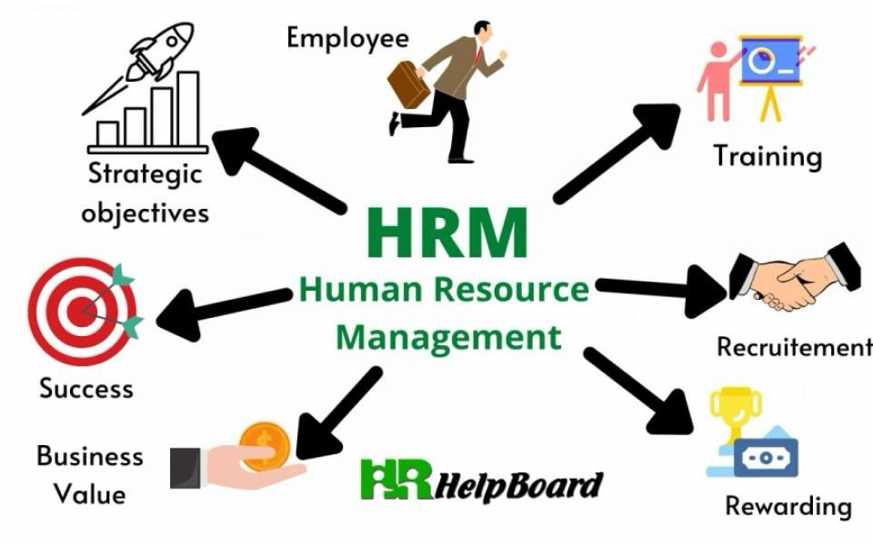

**Human Resource Management Definitions by Authors:**

**According to M. J. Jucious:**

“The field of HRM involves planning, [organization](https://hrmpractice.com/organization/), directing and controlling functions of procuring, developing, maintaining and utilizing a labor force.”

**According to Dale Yoder:**

“HRM is the provision of [leadership](https://hrmpractice.com/leadership/) and direction of people in their working or employment relationship.”

**Mathis and Jackson:** “HRM is the effective use of [Human resources](https://hrmpractice.com/human-resources/) and [organization](https://hrmpractice.com/organization/) through the [management](https://hrmpractice.com/management/) of people related activities.”

**According to Ricky W. Griffin:**

“[Human Resource Management](https://hrmpractice.com/hello-world/) is the set of organizational activities directed at attracting, developing and maintaining an effective workforce.”

**According to Gray Dessler:**

“The policies and practices one needs to carry out the people or [human resource](https://hrmpractice.com/human-resource/) aspects of a [management](https://hrmpractice.com/management/) position, including recruiting, screening, training, rewarding, and appraising.”

**According to Milkovich & Boudreau:**

“[Human Resource Management](https://hrmpractice.com/hello-world/) is a series of decision that affect the relationship between employee and employer: it affects many constituencies and is intended to influences the effectiveness of employee and employer.

**SCOPE OF HRM:-**

* The scope of Human Resource Management (HRM) encompasses a wide range of activities and responsibilities aimed at managing an organization's workforce. It includes:

1. **Recruitment and Selection:**

Attracting, hiring, and placing the right individuals in the organization.

1. **Training and Development:**

Enhancing employees' skills and knowledge to improve performance and meet organizational goals.

1. **Performance Management:**

Assessing and managing employee performance, setting goals, and providing feedback.

1. **Compensation and Benefits:**

Designing and managing salary structures, bonuses, and benefits to attract and retain talent.

1. **Employee Relations:**

Handling employee issues, grievances, and fostering a positive work environment.

1. **HR Planning:**

Forecasting future workforce needs and planning for recruitment, training, and development accordingly.

1. **Employee Engagement:**

Promoting a positive workplace culture, job satisfaction, and employee well-being.

1. **Legal Compliance:**

Ensuring compliance with labor laws, regulations, and ethical standards.

1. **Diversity and Inclusion:**

Fostering a diverse and inclusive workplace that values and respects individuals from different backgrounds.

1. **Strategic HRM:**

Aligning HR practices with overall organizational goals and strategies.

1. **Talent Management:**

Identifying, developing, and retaining high-potential employees.

1. **Organizational Development:**

Facilitating organizational change and ensuring the alignment of human resources with business objectives.

The scope of HRM is dynamic and evolves with changes in organizational structures, workforce demographics, and business environments. It plays a crucial role in supporting the overall success and sustainability of an organization by effectively managing its human capital.

**SIGNIFICANCE OF HUMAN RESOURCE MANAGEMENT (HRM)**

* The significance of Human Resource Management (HRM) lies in its critical role in contributing to organizational success and effectiveness.
* Here are some key aspects of its significance:

1. **Talent Acquisition and Retention:**

HRM is crucial for attracting, selecting, and retaining the right talent. A skilled and motivated workforce contributes significantly to an organization's competitiveness and success.

1. **Employee Development:**

HRM ensures the continuous development of employees through training and education programs. This contributes to improved skills, enhanced performance, and career growth.

1. **Performance Management:**

HRM establishes systems for assessing and managing employee performance, promoting accountability, and aligning individual goals with organizational objectives.

1. **Workplace Culture and Employee Engagement:**

HRM plays a pivotal role in shaping a positive workplace culture that fosters teamwork, collaboration, and employee engagement. A satisfied and engaged workforce is more likely to contribute to organizational goals.

1. **Legal Compliance:**

HRM ensures that organizations adhere to labor laws, regulations, and ethical standards, reducing the risk of legal issues and fostering a fair and compliant work environment.

1. **Conflict Resolution:**

HRM is responsible for managing employee relations and resolving conflicts, contributing to a harmonious work environment and maintaining a healthy employer-employee relationship.

1. **Strategic Alignment:**

HRM aligns human resources strategies with overall organizational goals, ensuring that the workforce supports and advances the company's mission and vision.

1. **Cost Efficiency:**

Effective HRM practices can lead to cost savings by optimizing workforce utilization, reducing turnover, and improving overall productivity.

1. **Innovation and Change Management:**

HRM supports organizational adaptability by facilitating innovation and managing change. This includes fostering a culture that embraces new ideas and managing transitions effectively.

1. **Global Perspective:**

In a globalized business environment, HRM is vital for managing diverse workforces, understanding different cultural nuances, and ensuring effective communication across borders.

1. **Succession Planning:**

HRM is involved in identifying and developing future leaders within the organization, ensuring a smooth transition of leadership and maintaining continuity.

Human Resource Management is significant because it contributes to creating a motivated, skilled, and well-aligned workforce that is essential for achieving organizational goals and maintaining a competitive edge in the dynamic business environment.

Top of Form

Top of Form

**OBJECTIVES OF HUMAN RESOURCES MANAGEMENT:**

HRM can be broken down into the following four category objectives:

1. **Societal objectives-**

These are measures put in place to respond to the ethical and social needs or challenges of the company and its employees. This includes legal issues such as equal opportunity and equal pay for equal work.

1. **Organizational objectives-**

These are actions taken to ensure organizational efficiency, including providing the appropriate training, hiring the right number of employees for a given task and maintaining high [employee retention](https://www.techtarget.com/searchhrsoftware/definition/employee-retention) rates.

1. **Functional objectives-**

These are the guidelines used to keep HR functioning properly within the organization. They include ensuring all HR resources are allocated to their full potential.

1. **Personal objectives-**

These are the resources used to support the personal goals of each employee. They include opportunities for education and career development, as well as maintaining employee satisfaction.

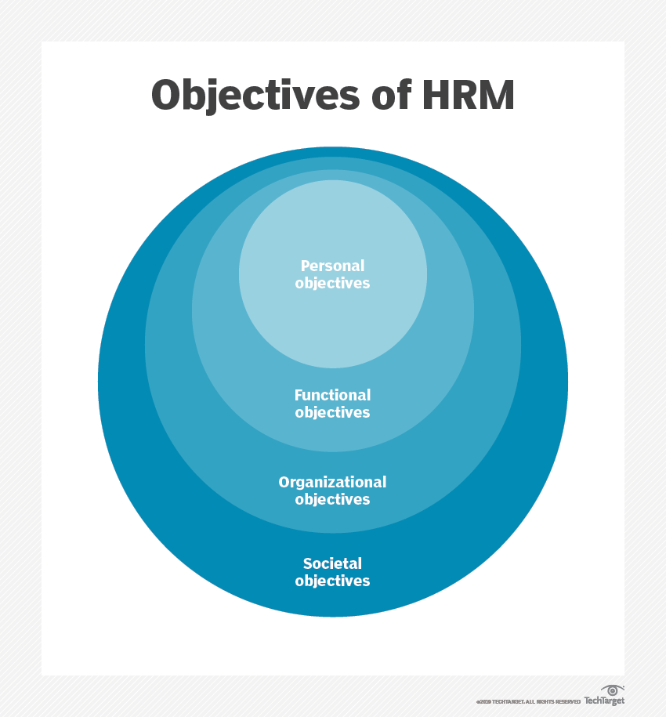**Top of Form**



**FUNCTION OF HR DEPARTMENT:**

* Human Resource Management (HRM) involves a range of functions that are essential for managing an organization's workforce effectively.
* The key functions of HRM include:

1. **Recruitment and Selection:**
   * Attracting, sourcing, and hiring qualified candidates to meet organizational needs.
   * Conducting job analyses to determine staffing requirements.
   * Developing job descriptions and specifications.
2. **Training and Development:**
   * Identifying training needs and designing programs to enhance employee skills.
   * Providing ongoing learning opportunities for career development.
   * Implementing employee development initiatives.
3. **Performance Management:**
   * Establishing performance standards and expectations.
   * Conducting performance appraisals and providing constructive feedback.
   * Recognizing and rewarding high performance.
4. **Compensation and Benefits:**
   * Designing and managing competitive salary structures.
   * Administering employee benefits, such as health insurance and retirement plans.
   * Ensuring fair and equitable compensation practices.
5. **Employee Relations:**
   * Handling employee grievances and conflicts.
   * Promoting a positive work environment and fostering employee engagement.
   * Managing communication between employees and management.
6. **Legal Compliance:**
   * Ensuring compliance with labor laws, regulations, and workplace standards.
   * Implementing policies and procedures to minimize legal risks.
7. **Diversity and Inclusion:**
   * Promoting diversity and creating an inclusive workplace culture.
   * Implementing initiatives to ensure equal opportunities for all employees.
8. **HR Planning and Forecasting:**
   * Anticipating and planning for future workforce needs.
   * Conducting workforce analysis and planning for succession.
9. **Strategic HRM:**
   * Aligning HR practices with overall organizational goals and strategies.
   * Contributing to the development and execution of business strategies.
10. **Employee Health and Safety:**
    * Ensuring a safe and healthy work environment.
    * Implementing safety protocols and programs.

These functions collectively aim to optimize the performance and well-being of an organization's workforce, contributing to the achievement of business objectives and overall success.

**Personnel Policies  – Meaning**

* Personal policies refer to a set of guidelines and rules established by an organization to govern the behavior, conduct, and expectations of individual employees.
* The term ‘personnel policy’ is an amalgam of two words – ‘Personnel’ and ‘Policy’ which denotes ‘men made rules, procedures’, etc.
* It refer to a set of guidelines and rules established by an organization to govern the behavior, actions, and expectations of its employees.
* These policies are designed to ensure a fair, consistent, and productive work environment.
* Personal policies cover a wide range of areas, including employee conduct, work hours, leave policies, performance expectations, and various other aspects of the employer-employee relationship.
* Thus, personnel policies constitute guide to action. They furnish the general standards or basis on which decisions are made.
* **Examples:**

**Code of Conduct:** Outlines expected behavior and ethical standards for employees.

**Dress Code:** Defines acceptable workplace attire and grooming standards.

* **Social Media Use:** Establishes guidelines for the appropriate use of social media in relation to the organization.

**CHARACTERISTICS OF PERSONNEL POLICIES**

**During the course of formulation of personnel policy, the management should consider the following points:**

1. It should be in written form.

2. It should be clear, positive and early understood by each and every employee of the organization

3. It should be in the line of corporate objectives.

4. It should be in local language also.

5. It should be generally known to all interested parties.

6. It should be reasonably stable but not rigid.

7. It should be built on the basis of facts and sound judgement.

8. It should provide two way communication system between the management and the employees of the organization.

9. It should be fair and equitable to internal as well as external groups.

10. It should be consistent with public policy.

**PERSONAL POLICIES OBJECTIVES:**

* Personal policies within an organization serve several important objectives, contributing to the overall effectiveness, fairness, and success of the workforce.
* The specific objectives may vary depending on the organization's values, industry, and overall goals. Here are some common objectives of personal policies:

1. **Establishing Expectations:**
   * **Objective:** Clearly communicate the organization's expectations regarding employee behavior, conduct, and performance.
   * **Rationale:** Helps set a standard for professionalism, ethics, and work-related behavior, fostering a positive workplace culture.
2. **Ensuring Fair Treatment:**
   * **Objective:** Promote fairness and consistency in how employees are treated across all levels of the organization.
   * **Rationale:** Prevents discrimination and bias, creating an inclusive and equitable work environment.
3. **Legal Compliance:**
   * **Objective:** Ensure that the organization adheres to local, regional, and national labor laws and regulations.
   * **Rationale:** Mitigates legal risks and liabilities, protecting both the organization and its employees.
4. **Protecting Employee Rights:**
   * **Objective:** Safeguard the rights and privileges of employees within the workplace.
   * **Rationale:** Enhances job satisfaction and employee morale, contributing to a positive employee experience.
5. **Promoting a Safe Work Environment:**
   * **Objective:** Establish guidelines for workplace safety and health.
   * **Rationale:** Reduces the risk of accidents and injuries, contributing to the overall well-being of employees.
6. **Facilitating Communication:**
   * **Objective:** Provide a framework for effective communication within the organization.
   * **Rationale:** Helps prevent misunderstandings and promotes transparent communication between employees and management.
7. **Supporting Organizational Goals:**
   * **Objective:** Align personal policies with the broader goals and objectives of the organization.
   * **Rationale:** Ensures that employee actions contribute to the overall success and mission of the organization.
8. **Improving Employee Performance:**
   * **Objective:** Set clear expectations for job performance and conduct performance evaluations.
   * **Rationale:** Motivates employees to meet and exceed performance standards, contributing to organizational success.
9. **Enhancing Employee Engagement:**
   * **Objective:** Foster a positive work environment that encourages employee engagement and commitment.
   * **Rationale:** Engaged employees are more likely to be productive, satisfied, and loyal to the organization.
10. **Managing Employee Relations:**
    * **Objective:** Provide guidelines for managing conflicts, grievances, and employee relations issues.
    * **Rationale:** Helps maintain a harmonious workplace and resolves issues in a fair and consistent manner.
11. **Adapting to Change:**
    * **Objective:** Enable the organization to adapt to changes in the business environment or industry.
    * **Rationale:** Supports organizational agility and resilience in the face of change.

* The objectives of personal policies encompass creating a positive and inclusive work environment, ensuring legal compliance, promoting fairness and consistency, and aligning employee actions with the overall goals of the organization.
* These objectives collectively contribute to the effective management of the workforce and the success of the organization.

**PROGRAMS:**

* **Definition:**
* Programs in the context of HRM refer to systematic and coordinated initiatives or activities designed to achieve specific organizational objectives related to human resources.
* HR programs are systematic and coordinated sets of initiatives or activities strategically designed to achieve specific organizational objectives related to human resources.
* These programs are proactive and often involve a series of planned actions to enhance various aspects of the workforce.
* **Purpose:**

HR programs aim to address various aspects of employee development, engagement, and organizational effectiveness.

* **Examples:**
  + **Employee Training Program:** Designed to enhance skills, knowledge, and capabilities of employees.
  + **Employee Wellness Program:** Promotes the health and well-being of employees through various initiatives.
  + **Diversity and Inclusion Program:** Fosters a diverse and inclusive workplace culture.

**PROCEDURES:**

* **Definition:**
* Procedures are step-by-step instructions or guidelines that outline how specific tasks or processes should be carried out within an organization.
* Procedures are detailed, step-by-step instructions or guidelines that prescribe how specific tasks or processes should be carried out within an organization.
* They provide a structured framework to ensure that activities are performed consistently and in accordance with established standards and policies.
* Procedures are essential tools for organizations to ensure consistency, efficiency, and compliance in their day-to-day operations.
* They offer a structured approach to various tasks and processes, providing clarity and guidance for employees at all levels of the organization.
* **Purpose:**

Procedures provide a standardized approach to tasks, ensuring consistency, efficiency, and compliance with organizational policies.

* **Examples:**
  + **Onboarding Procedure:** Details the steps for welcoming and integrating new employees into the organization.
  + **Performance Appraisal Procedure:** Outlines the process for conducting employee performance evaluations.
  + **Leave Request Procedure:** Describes the steps employees need to follow when requesting time off.

**TYPES OF PERSONAL POLICIES:**

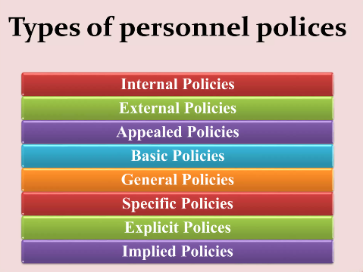

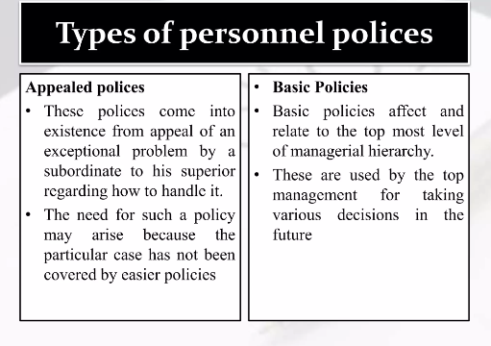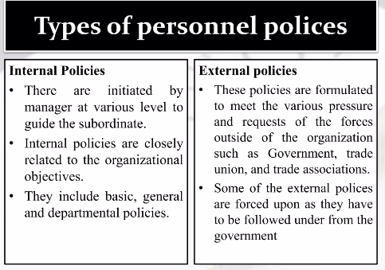

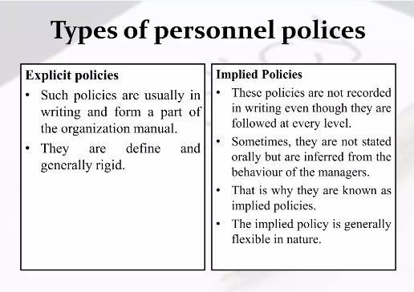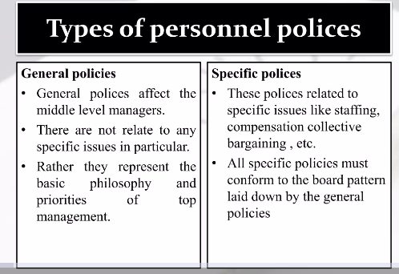

**Personnel Policies – Top 6 Principles:**

* Due to the pervasive nature of personnel function it becomes very important and essential to have a group of sound personnel policies in the organisation.

**The main principles which must be observed in framing personnel policies are as follows:**

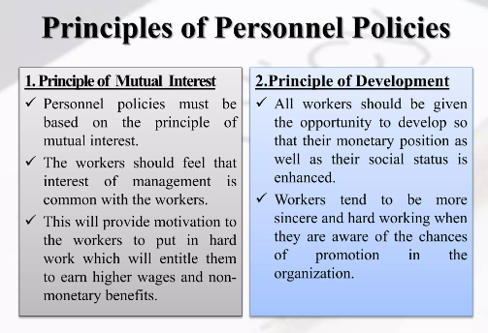

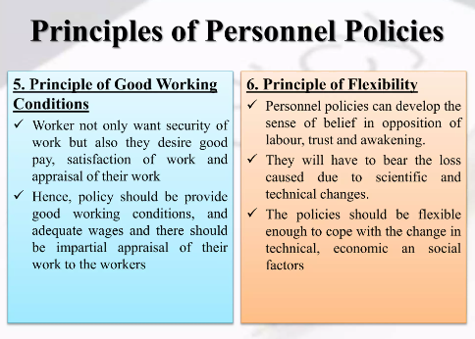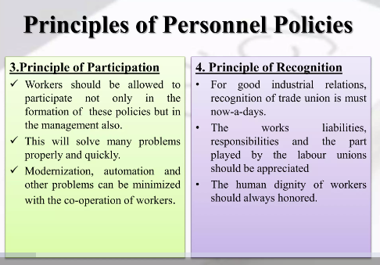

**MANPOWER MANAGEMENT:**

* Manpower Planning which is also called as Human Resource Planning consists of putting right number of people, right kind of people at the right place, right time, doing the right things for which they are suited for the achievement of goals of the organization.
* Human Resource Planning has got an important place in the arena of industrialization.
* Human Resource Planning has to be a systems approach and is carried out in a set procedure.
* Manpower management, also known as human resource management (HRM) or workforce management, involves the strategic planning, acquisition, development, utilization, and retention of an organization's workforce.
* It encompasses a comprehensive approach to managing people, aligning their skills and capabilities with organizational goals, and creating an environment that fosters productivity, engagement, and employee well-being.

**Need for Manpower Planning:**

* Manpower Planning is a two-phased process because manpower planning not only analyses the current human resources but also makes manpower forecasts and thereby draw employment programmes.
* Manpower Planning is advantageous to firm in following manner:

1. Shortages and surpluses can be identified so that quick action can be taken wherever required.
2. All the recruitment and selection programmes are based on manpower planning.
3. It also helps to reduce the labour cost as excess staff can be identified and thereby overstaffing can be avoided.
4. It also helps to identify the available talents in a concern and accordingly training programmes can be chalked out to develop those talents.
5. It helps in growth and diversification of business. Through manpower planning, human resources can be readily available and they can be utilized in best manner.
6. It helps the organization to realize the importance of manpower management which ultimately helps in the stability of a concern.

**ESTIMATING MANPOWER REQUIREMENT:**

* Estimating manpower requirement means finding out number and type of employees.
* Type here means qualification and educational background of people to be recruited.
* Estimating manpower requirement involves the systematic process of determining the quantity and quality of human resources needed by an organization to meet its current and future objectives.
* This process includes analyzing various factors such as the volume and nature of work, technological changes, production/service demands, and organizational goals.
* The goal is to ensure that the organization has the right number of employees with the necessary skills and qualifications in place to fulfill its operational and strategic needs.

1. **Workload Analysis:**
   * **Definition:** Evaluating the volume and type of work that needs to be accomplished within the organization.
2. **Job Analysis:**
   * **Definition:** Examining individual roles within the organization to identify tasks, responsibilities, and required qualifications.
3. **Production or Service Requirements:**
   * **Definition:** Assessing the level of production or service delivery needed to meet organizational goals.
4. **Technological Changes:**
   * **Definition:** Evaluating how advancements in technology may impact the skills and competencies required.
5. **Organizational Goals and Strategic Planning:**
   * **Definition:** Aligning workforce planning with the overall goals and strategic direction of the organization.

**JOB ANALYSIS-**

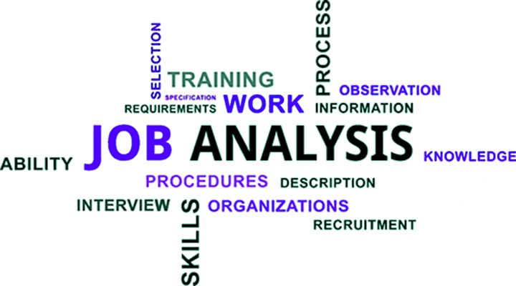

* Job analysis is the process of gathering and analyzing information about the content and the human requirements of jobs, as well as, the context in which jobs are performed.
* This process is used to determine placement of jobs.
* A job analysis is a systematic process of identifying and determining the responsibilities, requirements, and nature of a job in detail.
* It involves breaking the job into smaller units, collecting data on each unit, and then analyzing the data to determine to establish the skills and competencies the role requires.
* Job analysis is the process of systematically gathering, documenting, and analyzing information about a job.
* It involves identifying and describing the duties, responsibilities, tasks, and qualifications associated with a specific position within an organization.
* Job analysis is a systematic process of gathering, documenting, and analyzing information about a job.
* It involves studying and understanding the duties, responsibilities, tasks, qualifications, and working conditions associated with a particular position within an organization.
* The goal of job analysis is to provide a detailed and accurate description of a job's essential elements, forming the foundation for various HR functions such as recruitment, selection, training, performance appraisal, and compensation.
* The **Job Analysis** is a systematic process of gathering complete information about the job duties and responsibilities required to perform a specific job.

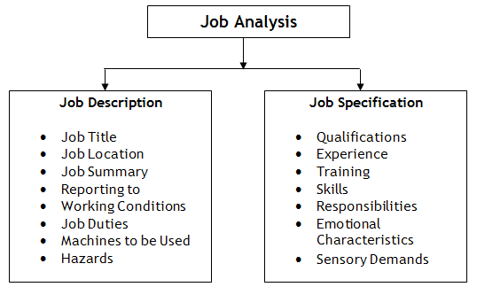

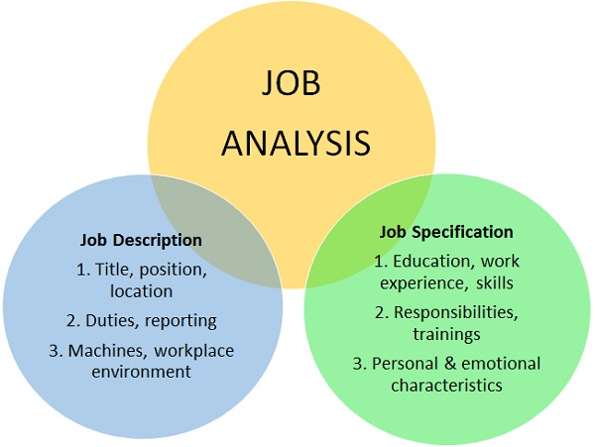

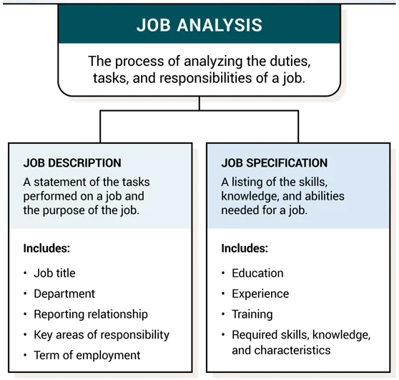

**Job Analysis Methods**

There are several ways a company might perform a job analysis:

* **Observation:** Observation is when a manager observes an employee in a role for a period of time. They might sit with their employees for several days to understand the tasks they perform, their methods and the qualities they have.
* **Interview:** The interview method is when a manager might ask their employee's different questions about an employee's role. This helps understand what specific needs a role has, what tools they use and how they spend their time.
* **Daily:** The daily method is when an employee notes their daily activities. This might be for a week or longer, detailing when they send emails, have meetings and perform other professional tasks before a manager organises the information into a detailed analysis.
* **Questionnaire:** The questionnaire method is similar to the interview method but involves written questions an employee can answer about their role.

**PROCESS OF JOB ANALYSIS:**

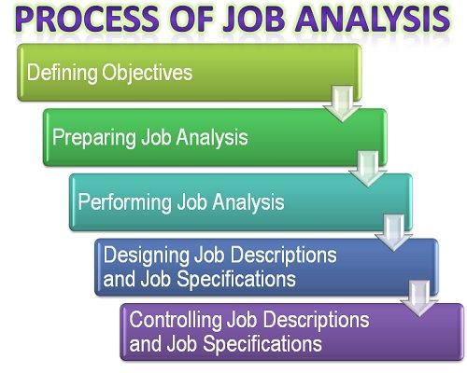

1. **Defining the objectives:**

* The foremost step in the process of job analysis is defining the objective of the job analysis.
* The objective could be either of the following:
  + Redesign the job description
  + Revise the compensation program
  + Change the organization structure
  + Redesign the job in a particular department. Once the objective is selected, it should be well communicated to the top management because with its support only, the changes can be made in the organization.

1. **Preparing the job Analysis:**

* After setting an objective, the kind of jobs that are to be analyzed are selected, whether the clerical jobs, managerial jobs, division specific job, etc.
* Also, the members who are included in the analysis and the methods to be used are identified.
* At this stage, the complete review of the existing job description is done to have a fair insight of the duties, responsibilities, organization chart, working conditions, hazards, etc. that exist in a particular set of jobs.

1. **Performing the Job Analysis:**

* The next stage in the process of job analysis is to perform or begin with the job analysis.
* Here, the sufficient time should be allotted for collecting the job details from the employees.
* The information from the employees can be collected through questionnaires, interviews, or through an observation method.
* Once the information gets collected it needs to be sorted on the basis of its nature, division, department.

1. **Designing Job Descriptions and Job Specifications**:

* At this stage, the job analyst prepares a draft of the job description and the specifications.
* After sorting of the information, the changes that need to be made in the jobs is identified and is written on paper.
* Once the draft gets prepared, it is circulated to the managers, supervisors, and the employees.

1. **Control Job Descriptions and Job Specifications:**

* This is the last step in the process of job analysis wherein the job descriptions, and the specifications are timely checked and modified according to the changing needs of the organization.
* The job analysis results in the**job description** and the**job specification**.
* The Job description comprises of job duties, the level of responsibilities, working conditions, etc. and whereas the job specification tells about the skills, education, background, qualification, training, communication skills required to perform a specific job.

**JOB DESCRIPTION:**

* A job description is a written explanation that outlines the essential responsibilities and requirements for a vacant position.
* Job descriptions should be thorough, clear, and concise and include:
* A brief introduction to the company and its mission.
* An overview of the job responsibilities.
* The necessary skills, competence levels, knowledge, and qualifications relevant candidates should have.
* Testing that the company may require.
* Working conditions and location. It should also cover whether the role is office-based, remote, or hybrid.
* Environmental factors or strenuous components of the job.
* The [type of employment](https://www.hibob.com/hr-glossary/employee-type/)—full-time, part-time, or independent contractor.
* A job description is a document that clearly states essential job requirements, job duties, job responsibilities, and skills required to perform a specific role.
* A detailed job description will cover how success is measured in the role so it can be used in performance evaluations.

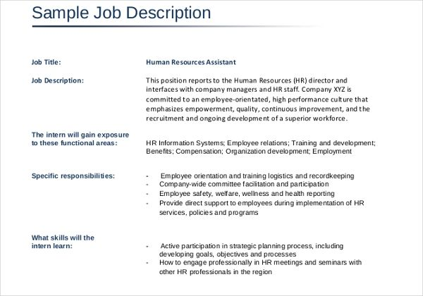

**STEPS TO WRITE A JOB DESCRIPTION:**

Companies have to make sure that they write an accurate & comprehensive job description giving all job-related details. The main steps to write a job description are:

**1. Job Title**

The first step is to write the job title decided internally for official purposes.

**2. Role Summary**

The second step is to write the summary about the job role.

**3. Duties**

The next step involves writing down all the job responsibilities as well as the job duties which are required with this particular job.

**4. Qualifications**

The fourth step is to give the basic education qualifications, work experience or other criteria required for this job role.

**5. Role Expectations**

This step defines what is required by an employee to be successful.

**6. Reporting**

The sixth step is to highlight who the reporting manager would be and who would be the subordinates.

**7. Verification**

The final step is to get the job description verified by the HR team for any changes, updates or validations.

**COMPONENTS OF JOB DESCRIPTION**

A Job description will include the following components:

- Roles and responsibilities of the job.

- Goals of the organization as well the goals to be achieved as a part of the profile are mentioned in the job description.

- Qualifications in terms of education and work experience required have to be clearly mentioned.

- Skill sets like leadership, team management, time management, communication management etc required to fulfill the job

- Salary range of the job are mentioned in the job description

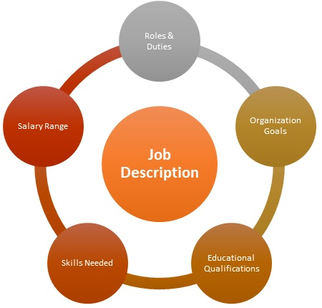

**JOB SPECIFICATION:**

* A job specification is a detailed description of the qualifications, skills, knowledge, and other characteristics that a person needs to have in order to successfully perform a specific job.
* It outlines the requirements and expectations for a particular position, helping both employers and job seekers understand what is needed for the role.

1. **Job Title:** The name of the position.
2. **Education:** The required level of education or qualifications.
3. **Experience:** The necessary work background for the job.
4. **Skills:** The specific abilities and talents needed.
5. **Responsibilities:** The tasks and duties associated with the job.
6. **Working Conditions:** The environment and circumstances in which the job is performed.
7. **Salary Range:** The possible pay for the position.
8. **Other Requirements:** Any additional qualifications or characteristics needed for success in the role.

Job specifications help both employers and job seekers understand what is expected for a particular job.

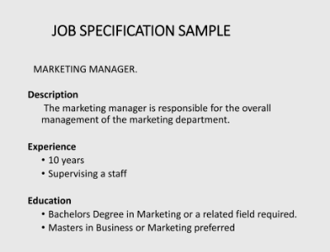

**DIFFERENCE BETWEEN JOB DESCRIPTION AND JOB SPECIFICATION**

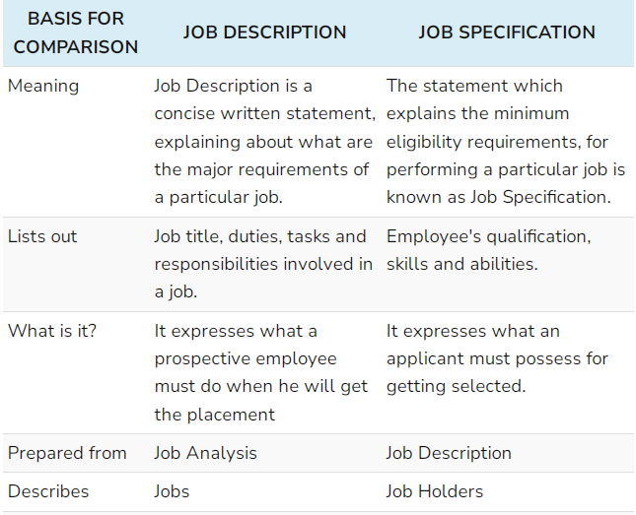

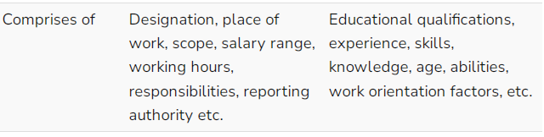

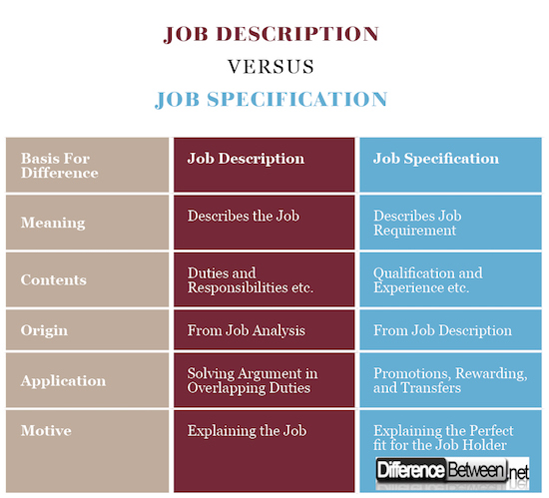

**MCQ’S:**

1. **Question: What is the primary focus of Human Resource Management (HRM)?**

A. Managing financial resources

B. Managing human talent

C. Managing technology

D. Managing physical resources

**Answer: B. Managing human talent**

1. **Question: In HRM, what does the term "human capital" refer to?**

A. Physical assets of employees

B. Intellectual and collective skills of employees

C. Financial resources of employees

D. Employee job titles

**Answer: B. Intellectual and collective skills of employees**

1. **Question: What is the primary goal of HRM?**

A. Maximizing profits

B. Enhancing employee satisfaction

C. Minimizing technology usage

D. Ignoring organizational objectives

**Answer: B. Enhancing employee satisfaction**

1. **Question: How does HRM contribute to organizational success?**

A. By ignoring employee needs

B. By maximizing financial resources

C. By managing and developing human resources effectively

D. By minimizing employee involvement

**Answer: C. By managing and developing human resources effectively**

1. **Question: What is the significance of HRM in modern organizations?**

A. Reducing employee satisfaction

B. Enhancing organizational efficiency and effectiveness

C. Ignoring employee development

D. Minimizing employee engagement

**Answer: B. Enhancing organizational efficiency and effectiveness**

1. **Question: Which of the following is NOT a component of HRM?**

A. Recruitment and selection

B. Financial management

C. Employee training and development

D. Performance appraisal

**Answer: B. Financial management**

1. **Question: In HRM, what role does HR planning play?**

A. Ignoring organizational goals

B. Forecasting and aligning human resources with organizational objectives

C. Reducing workforce diversity

D. Minimizing employee morale

**Answer: B. Forecasting and aligning human resources with organizational objectives**

1. **Question: Why is HRM considered a strategic function in organizations?**

A. To promote workplace conflicts

B. To maximize employee turnover

C. To align human resources with organizational goals

D. To ignore employee training

**Answer: C. To align human resources with organizational goals**

1. **Question: What does the term "employee empowerment" mean in the context of HRM?**

A. Limiting employee decision-making

B. Enhancing employee involvement and autonomy

C. Reducing employee responsibilities

D. Ignoring employee feedback

**Answer: B. Enhancing employee involvement and autonomy**

1. **Question: Which of the following is a key element of HRM's role in employee relations?**

A. Promoting discrimination

B. Resolving workplace conflicts

C. Ignoring employee concerns

D. Minimizing communication

**Answer: B. Resolving workplace conflicts**

1. **Question: What is the purpose of job analysis in HRM?**

A. Determining employee salaries

B. Identifying training needs and job requirements

C. Promoting workplace conflicts

D. Ignoring employee performance

**Answer: B. Identifying training needs and job requirements**

1. **Question: What role does HRM play in talent management?**

A. Minimizing employee engagement

B. Attracting, developing, and retaining skilled employees

C. Ignoring employee training opportunities

D. Reducing workforce diversity

**Answer: B. Attracting, developing, and retaining skilled employees**

1. **Question: In HRM, what does the term "workforce diversity" refer to?**

A. Limiting the types of employees in an organization

B. Embracing individual differences among employees

C. Ignoring cultural sensitivity

D. Reducing employee engagement

**Answer: B. Embracing individual differences among employees**

1. **Question: Why is HRM responsible for employee training and development?**

A. To increase employee turnover

B. To improve employee performance and skills

C. To minimize employee involvement

D. To ignore organizational goals

**Answer: B. To improve employee performance and skills**

1. **Question: What is the primary goal of HRM in performance appraisal?**

A. Promoting favoritism

B. Ignoring employee performance

C. Evaluating and recognizing employee contributions

D. Reducing workplace conflicts

**Answer: C. Evaluating and recognizing employee contributions**

1. **Question: What is the primary objective of HRM's recruitment and selection process?**

A. To increase employee turnover

B. To minimize workforce diversity

C. To attract and hire the most qualified candidates

D. To ignore organizational goals

**Answer: C. To attract and hire the most qualified candidates**

1. **Question: In HRM, what does the term "compensation management" involve?**

A. Ignoring employee benefits

B. Managing employee salaries, bonuses, and benefits

C. Reducing employee engagement

D. Minimizing organizational efficiency

**Answer: B. Managing employee salaries, bonuses, and benefits**

1. **Question: What role does HRM play in promoting a positive organizational culture?**

A. Creating workplace conflicts

B. Fostering teamwork and collaboration

C. Ignoring employee feedback

D. Minimizing employee satisfaction

**Answer: B. Fostering teamwork and collaboration**

1. **Question: Why is HRM responsible for creating and implementing employee policies?**

A. To discourage workplace ethics

B. To increase employee turnover

C. To provide guidelines for employee behavior and expectations

D. To minimize communication within the organization

**Answer: C. To provide guidelines for employee behavior and expectations**

1. **Question: What is the primary focus of HRM's employee engagement initiatives?**

A. Reducing employee satisfaction

B. Enhancing employee commitment, motivation, and job satisfaction

C. Ignoring workplace culture

D. Minimizing employee involvement

**Answer: B. Enhancing employee commitment, motivation, and job satisfaction**

1. **Question: How does HRM contribute to organizational success through strategic planning?**

A. By avoiding organizational goals

B. By minimizing employee training opportunities

C. By aligning HR strategies with overall business objectives

D. By promoting workplace conflicts

**Answer: C. By aligning HR strategies with overall business objectives**

1. **Question: What is the purpose of an HR audit in the context of HRM?**

A. To increase employee dissatisfaction

B. To evaluate and improve HR policies and practices

C. To ignore employee concerns

D. To reduce organizational efficiency

**Answer: B. To evaluate and improve HR policies and practices**

1. **Question: Why is HRM involved in employee onboarding processes?**

A. To discourage new hires

B. To minimize communication with new employees

C. To help new employees integrate into the organization effectively

D. To avoid training new hires

**Answer: C. To help new employees integrate into the organization effectively**

1. **Question: What does the term "HR analytics" refer to in HRM?**

A. Managing financial resources

B. Using data and metrics to make strategic HR decisions

C. Ignoring employee performance

D. Reducing employee engagement

**Answer: B. Using data and metrics to make strategic HR decisions**

1. **Question: In HRM, what is the purpose of exit interviews?**

A. To discourage employee departures

B. To evaluate and improve HR policies

C. To minimize communication with departing employees

D. To avoid feedback from departing employees

**Answer: B. To evaluate and improve HR policies**

1. **Question: What is the role of HRM in promoting diversity and inclusion in the workplace?**

A. To discourage diverse hiring practices

B. To ignore cultural sensitivity

C. To create a workplace that values and respects individual differences

D. To minimize employee morale

**Answer: C. To create a workplace that values and respects individual differences**

1. **Question: How does HRM contribute to employee wellness programs?**

A. By promoting unhealthy work habits

B. By ignoring employee health

C. By implementing initiatives to support employee well-being

D. By minimizing communication about health issues

**Answer: C. By implementing initiatives to support employee well-being**

1. **Question: What is the significance of HRM's role in change management?**

A. To resist organizational change

B. To minimize employee involvement in change

C. To facilitate smooth transitions during periods of change

D. To discourage innovation

**Answer: C. To facilitate smooth transitions during periods of change**

1. **Question: What is the purpose of performance feedback in HRM?**

A. To ignore employee performance

B. To discourage employee development

C. To provide constructive feedback and improve performance

D. To minimize communication with employees

**Answer: C. To provide constructive feedback and improve performance**

1. **Question: How does HRM contribute to organizational ethics?**

A. By promoting unethical behavior

B. By ignoring ethical considerations

C. By establishing and enforcing ethical standards

D. By minimizing communication about ethical issues

**Answer: C. By establishing and enforcing ethical standards**

1. **Question: Which HR function involves finding and attracting potential job candidates?**

A. Training and development

B. Recruitment and selection

C. Employee relations

D. Compensation management

**Answer: B. Recruitment and selection**

1. **Question: What is the primary goal of HR planning?**

A. Reducing employee engagement

B. Aligning workforce with organizational goals

C. Minimizing workplace conflicts

D. Ignoring employee training

**Answer: B. Aligning workforce with organizational goals**

1. **Question: Employee training and development fall under which HR function?**

A. Compensation and benefits

B. Staffing

C. Training and development

D. Employee relations

**Answer: C. Training and development**

1. **Question: What is the purpose of performance appraisals in the HR department?**

A. Determine employee salaries

B. Measure and assess employee job performance

C. Ignore employee contributions

D. Minimize employee satisfaction

**Answer: B. Measure and assess employee job performance**

1. **Question: In HRM, what is the primary function of employee relations?**

A. Promoting conflicts among employees

B. Resolving workplace issues and fostering positive relations

C. Reducing workforce diversity

D. Ignoring employee concerns

**Answer: B. Resolving workplace issues and fostering positive relations**

1. **Question: What are personnel policies?**

A. Guidelines for managing finances

B. Guidelines for managing people-related issues

C. Only applicable to top-level management

D. Irrelevant in modern organizations

**Answer: B. Guidelines for managing people-related issues**

1. **Question: Why are personnel policies important for an organization?**

A. To create confusion among employees

B. To provide guidelines for employee behavior and expectations

C. To discourage employee development

D. To minimize workplace conflicts

**Answer: B. To provide guidelines for employee behavior and expectations**

1. **Question: What is the purpose of a code of conduct in HRM?**

A. To encourage unethical behavior

B. To establish guidelines for ethical behavior in the workplace

C. To discourage workplace diversity

D. To ignore employee concerns

**Answer: B. To establish guidelines for ethical behavior in the workplace**

1. **Question: Which personnel policy focuses on the termination process?**

A. Recruitment policy

B. Termination policy

C. Compensation policy

D. Training policy

**Answer: B. Termination policy**

1. **Question: What is the role of a sexual harassment policy in HRM?**

A. To promote a hostile work environment

B. To discourage reporting of harassment incidents

* + C. To provide guidelines for preventing and addressing sexual harassment

D. To minimize communication about harassment

**Answer: C. To provide guidelines for preventing and addressing sexual harassment**

1. **Question: Which HR program focuses on helping employees achieve work-life balance?**

A. Workforce diversity program

B. Employee recognition program

C. Employee assistance program

D. Flexible work arrangements program

**Answer: D. Flexible work arrangements program**

1. **Question: What is the purpose of an employee orientation program?**

A. To increase employee turnover

B. To provide new employees with information about the organization

C. To ignore workplace culture

D. To discourage communication with new hires

**Answer: B. To provide new employees with information about the organization**

1. **Question: In HRM, what does the term "career development program" involve?**

A. Ignoring employee career growth

B. Providing opportunities for employee skill enhancement and advancement

C. Discouraging employee promotions

D. Minimizing workforce diversity

**Answer: B. Providing opportunities for employee skill enhancement and advancement**

1. **Question: Which HR program focuses on recognizing and rewarding employee contributions?**

A. Employee relations program

B. Employee recognition program

C. Employee termination program

D. Employee training program

**Answer: B. Employee recognition program**

1. **Question: What is the purpose of a workplace safety program in HRM?**

A. To promote unsafe working conditions

B. To reduce employee engagement

C. To ensure a safe and healthy work environment

D. To ignore employee concerns about safety

**Answer: C. To ensure a safe and healthy work environment**

1. **Question: Which HR procedure involves documenting employee performance issues?**

A. Conflict resolution procedure

B. Performance appraisal procedure

C. Termination procedure

D. Grievance handling procedure

**Answer: B. Performance appraisal procedure**

1. **Question: What does the term "grievance handling procedure" involve in HRM?**

A. Ignoring employee complaints

B. Providing a structured process for addressing employee complaints

C. Promoting conflicts among employees

D. Reducing employee morale

**Answer: B. Providing a structured process for addressing employee complaints**

1. **Question: In HRM, what is the purpose of a diversity and inclusion procedure?**

A. To discourage workplace diversity

B. To provide guidelines for promoting diversity and inclusion

C. To ignore cultural sensitivity

D. To minimize employee engagement

**Answer: B. To provide guidelines for promoting diversity and inclusion**

1. **Question: What is the role of an employee discipline procedure in HRM?**

A. To encourage misconduct

B. To provide guidelines for addressing employee misconduct

C. To discourage communication about discipline

D. To minimize employee satisfaction

**Answer: B. To provide guidelines for addressing employee misconduct**

1. **Question: Which HR procedure focuses on managing employee benefits and compensation?**

A. Compensation management procedure

B. Employee training procedure

C. Recruitment and selection procedure

D. Employee relations procedure

**Answer: A. Compensation management procedure**

1. **Question: What is the purpose of a recruitment and selection procedure in HRM?**

A. To discourage the hiring process

B. To provide guidelines for attracting, selecting, and hiring employees

C. To ignore workforce planning

D. To minimize communication with job candidates

**Answer: B. To provide guidelines for attracting, selecting, and hiring employees**

1. **Question: Which HR procedure involves conducting exit interviews?**

A. Recruitment and selection procedure

B. Termination procedure

C. Employee orientation procedure

D. Employee recognition procedure

**Answer: B. Termination procedure**

1. **Question: What does the term "workplace accommodation procedure" involve in HRM?**

A. To discourage workplace accommodations

B. To provide guidelines for accommodating employees with disabilities

C. To ignore employee needs for accommodation

D. To minimize communication about accommodations

**Answer: B. To provide guidelines for accommodating employees with disabilities**

1. **Question: In HRM, what is the purpose of a performance improvement plan (PIP) procedure?**

A. To recognize top performers

B. To address and improve employee performance deficiencies

C. To minimize communication about performance issues

D. To encourage favoritism

**Answer: B. To address and improve employee performance deficiencies**

1. **Question: Which HR procedure involves documenting and addressing employee grievances?**

A. Recruitment and selection procedure

B. Employee discipline procedure

C. Grievance handling procedure

D. Employee recognition procedure

**Answer: C. Grievance handling procedure**

1. **Question: What is the role of a whistleblower procedure in HRM?**

A. To discourage reporting of unethical behavior

B. To minimize communication about unethical practices

C. To provide guidelines for reporting unethical behavior without fear of retaliation

D. To promote unethical behavior

**Answer: C. To provide guidelines for reporting unethical behavior without fear of retaliation**

1. **Question: Which HR procedure involves addressing employee complaints about workplace issues?**

A. Employee relations procedure

B. Employee recognition procedure

C. Employee orientation procedure

D. Employee discipline procedure

**Answer: A. Employee relations procedure**

1. **Question: What is the purpose of a flexible work arrangements procedure in HRM?**

A. To discourage work flexibility

B. To provide guidelines for alternative work schedules and arrangements

C. To minimize communication about work arrangements

D. To reduce employee satisfaction

**Answer: B. To provide guidelines for alternative work schedules and arrangements**

1. **Question: Which HR procedure involves documenting and managing employee attendance?**

A. Recruitment and selection procedure

B. Termination procedure

C. Attendance management procedure

D. Employee recognition procedure

**Answer: C. Attendance management procedure**

1. **Question: What is the purpose of an employee exit procedure in HRM?**

A. To discourage employee departures

B. To provide guidelines for a smooth employee exit process

C. To minimize communication with departing employees

D. To avoid feedback from departing employees

**Answer: B. To provide guidelines for a smooth employee exit process**

1. **Question: What is the primary goal of Manpower Planning?**

A. To minimize employee turnover

B. To align workforce with organizational goals

C. To ignore workforce needs

D. To discourage employee training

**Answer: B. To align workforce with organizational goals**

1. **Question: Why is Manpower Planning considered essential for organizations?**

A. To create workplace conflicts

B. To align human resources with business objectives

C. To minimize workforce diversity

D. To discourage employee development

**Answer: B. To align human resources with business objectives**

1. **Question: What does the term "Manpower Planning" refer to?**

A. Ignoring workforce needs

B. Forecasting and managing the human resource needs of an organization

C. Minimizing employee engagement

D. Reducing workforce efficiency

**Answer: B. Forecasting and managing the human resource needs of an organization**

1. **Question: In the context of Manpower Planning, what is the significance of anticipating future workforce requirements?**

A. To discourage workforce expansion

B. To proactively address staffing needs

C. To minimize employee satisfaction

D. To ignore organizational growth

**Answer: B. To proactively address staffing needs**

1. **Question: What role does Manpower Planning play in workforce optimization?**

A. To encourage overstaffing

B. To minimize workforce diversity

C. To ensure the right number of employees with the right skills are in place

D. To discourage employee empowerment

**Answer: C. To ensure the right number of employees with the right skills are in place**

1. **Question: What is the primary purpose of demand forecasting in Manpower Planning?**

A. To minimize workforce efficiency

B. To align workforce with organizational goals

C. To ignore future workforce needs

D. To estimate the number of employees needed in the future

**Answer: D. To estimate the number of employees needed in the future**

1. **Question: Why is supply forecasting essential in Manpower Planning?**

A. To discourage workforce development

B. To estimate the availability of qualified candidates in the job market

C. To ignore employee skills

D. To minimize workforce engagement

**Answer: B. To estimate the availability of qualified candidates in the job market**

1. **Question: What is the role of gap analysis in Manpower Planning?**

A. To encourage workforce shortages

B. To identify the difference between current workforce capabilities and future requirements

C. To minimize employee training opportunities

D. To discourage communication about workforce needs

**Answer: B. To identify the difference between current workforce capabilities and future requirements**

1. **Question: How does Manpower Planning contribute to cost-effective HR management?**

A. By discouraging cost-saving initiatives

B. By aligning staffing levels with organizational needs

C. By minimizing workforce efficiency

D. By ignoring employee benefits

**Answer: B. By aligning staffing levels with organizational needs**

1. **Question: What is the purpose of succession planning in Manpower Management?**

A. To discourage employee advancement

B. To identify and prepare employees for future leadership roles

C. To minimize workforce engagement

D. To ignore organizational growth

**Answer: B. To identify and prepare employees for future leadership roles**

1. **Question: In Manpower Planning, what does the term "skills inventory" refer to?**

A. Discouraging employee skill development

B. A database of employee skills, qualifications, and experiences

C. Ignoring workforce capabilities

D. Minimizing workforce diversity

**Answer: B. A database of employee skills, qualifications, and experiences**

1. **Question: How does Manpower Planning contribute to employee career development?**

A. By discouraging training opportunities

B. By identifying training needs and career paths for employees

C. By minimizing communication about career goals

D. By ignoring employee advancement

**Answer: B. By identifying training needs and career paths for employees**

1. **Question: What is the role of Manpower Planning in addressing workforce imbalances?**

A. To encourage overstaffing

B. To identify and rectify gaps or surpluses in the workforce

C. To discourage workforce diversity

D. To minimize employee empowerment

**Answer: B. To identify and rectify gaps or surpluses in the workforce**

1. **Question: How does Manpower Planning contribute to organizational agility?**

A. By promoting inflexible workforce structures

B. By ignoring workforce needs during changes

C. By adapting the workforce to meet changing business demands

D. By discouraging workforce flexibility

**Answer: C. By adapting the workforce to meet changing business demands**

1. **Question: What is the purpose of workforce utilization analysis in Manpower Planning?**

A. To encourage underutilization of employees

B. To identify ways to optimize the use of existing workforce resources

C. To discourage communication about workforce efficiency

D. To ignore employee workload

**Answer: B. To identify ways to optimize the use of existing workforce resources**

1. **Question: Why is monitoring and evaluation crucial in the Manpower Planning process?**

A. To discourage workforce optimization

B. To assess the effectiveness of the planning efforts and make necessary adjustments

C. To minimize employee satisfaction

D. To ignore organizational goals

**Answer: B. To assess the effectiveness of the planning efforts and make necessary adjustments**

1. **Question: What is the significance of employee engagement in the context of Manpower Planning?**

A. To discourage employee commitment

B. To align employee interests with organizational goals

C. To minimize communication with employees

D. To ignore workforce diversity

**Answer: B. To align employee interests with organizational goals**

1. **Question: How does Manpower Planning contribute to talent management?**

A. By discouraging the identification and development of key talents

B. By aligning workforce skills with talent needs

C. By ignoring employee potential

D. By minimizing communication about talent development

**Answer: B. By aligning workforce skills with talent needs**

1. **Question: What is the role of technology in modern Manpower Planning processes?**

A. To discourage the use of technology in workforce management

B. To minimize communication about technological advancements

C. To leverage technology for data analysis and forecasting

D. To ignore the impact of technology on the workforce

**Answer: C. To leverage technology for data analysis and forecasting**

1. **Question: In Manpower Planning, what is the primary objective of workforce development programs?**

A. To discourage employee learning

B. To align workforce skills with future organizational needs

C. To minimize communication about training opportunities

D. To ignore employee career goals

**Answer: B. To align workforce skills with future organizational needs**

1. **Question: What is the primary goal of estimating manpower requirements in an organization?**

A. To discourage workforce planning

B. To align workforce with organizational goals

C. To minimize employee engagement

D. To ignore job roles

**Answer: B. To align workforce with organizational goals**

1. **Question: Why is demand forecasting essential in estimating manpower requirements?**

A. To encourage overstaffing

B. To estimate the future workforce needs of the organization

C. To discourage employee training

D. To minimize workforce diversity

**Answer: B. To estimate the future workforce needs of the organization**

1. **Question: What does supply forecasting involve in the context of estimating manpower requirements?**

A. Estimating the demand for products

B. Anticipating the availability of qualified candidates in the job market

C. Ignoring workforce capabilities

D. Discouraging employee empowerment

**Answer: B. Anticipating the availability of qualified candidates in the job market**

1. **Question: How does gap analysis contribute to estimating manpower requirements?**

A. By encouraging overstaffing

B. By identifying the difference between current workforce capabilities and future requirements

C. By discouraging communication about workforce needs

D. By minimizing employee satisfaction

**Answer: B. By identifying the difference between current workforce capabilities and future requirements**

1. **Question: What is the purpose of a skills inventory in estimating manpower requirements?**

A. To discourage workforce optimization

B. To identify the skills and qualifications of current employees

C. To minimize communication about workforce capabilities

D. To ignore job analysis

**Answer: B. To identify the skills and qualifications of current employees**

1. **Question: How does technology contribute to the accuracy of estimating manpower requirements?**

A. By discouraging the use of technology in workforce planning

B. By minimizing communication about technological advancements

C. By leveraging technology for data analysis and forecasting

D. By ignoring the impact of technology on the workforce

**Answer: C. By leveraging technology for data analysis and forecasting**

1. **Question: What role does succession planning play in estimating manpower requirements?**

A. To encourage employee turnover

B. To identify and prepare employees for future roles

C. To minimize communication about workforce development

D. To ignore workforce diversity

**Answer: B. To identify and prepare employees for future roles**

1. **Question: Why is monitoring and evaluation crucial in the process of estimating manpower requirements?**

A. To discourage workforce development

B. To assess the effectiveness of the planning efforts and make necessary adjustments

C. To minimize employee satisfaction

D. To ignore organizational goals

* + **Answer: B. To assess the effectiveness of the planning efforts and make necessary adjustments**

1. **Question: In manpower planning, what does the term "workforce utilization analysis" involve?**

A. Encouraging underutilization of employees

B. Identifying ways to optimize the use of existing workforce resources

C. Discouraging communication about workforce efficiency

D. Ignoring employee workload

**Answer: B. Identifying ways to optimize the use of existing workforce resources**

1. **Question: How does estimating manpower requirements contribute to cost-effective HR management?**

A. By discouraging cost-saving initiatives

B. By aligning staffing levels with organizational needs

C. By minimizing workforce efficiency

D. By ignoring employee benefits

**Answer: B. By aligning staffing levels with organizational needs**

1. **Question: What is the primary purpose of job analysis in human resource management?**

A. To discourage workplace efficiency

B. To identify and document the duties, responsibilities, and requirements of a job

C. To minimize communication about job roles

D. To ignore employee development

**Answer: B. To identify and document the duties, responsibilities, and requirements of a job**

1. **Question: Why is job analysis considered a foundational HR activity?**

A. To encourage workforce dissatisfaction

B. To establish the basis for various HR functions, such as recruitment, training, and compensation

C. To minimize employee engagement

D. To ignore organizational goals

**Answer: B. To establish the basis for various HR functions, such as recruitment, training, and compensation**

1. **Question: What information does job analysis typically include?**

A. Only employee names and contact details

B. Employee salaries and bonuses

C. Job duties, responsibilities, qualifications, and skills required

D. Employee personal preferences

**Answer: C. Job duties, responsibilities, qualifications, and skills required**

1. **Question: How does job analysis contribute to effective recruitment and selection processes?**

A. By discouraging the identification of job requirements

B. By minimizing communication about job roles

C. By providing a clear understanding of the skills and qualifications needed for a position

D. By ignoring workforce capabilities

**Answer: C. By providing a clear understanding of the skills and qualifications needed for a position**

1. **Question: What role does job analysis play in performance appraisal?**

A. To discourage employee recognition

B. To minimize communication about employee performance

C. By providing the criteria for evaluating employee performance

D. By ignoring employee job roles

**Answer: C. By providing the criteria for evaluating employee performance**

1. **Question: In job analysis, what does the term "job description" refer to?**

A. A document outlining the duties, responsibilities, qualifications, and skills required for a specific job

B. A list of employee names and contact details

C. A document discouraging communication about job roles

D. A document minimizing workforce diversity

**Answer: A. A document outlining the duties, responsibilities, qualifications, and skills required for a specific job**

1. **Question: Why is job analysis crucial for developing effective training programs?**

A. To discourage employee skill development

B. By identifying the skills and knowledge needed for successful job performance

C. To minimize communication about training opportunities

D. By ignoring employee career goals

**Answer: B. By identifying the skills and knowledge needed for successful job performance**

1. **Question: How does job analysis contribute to workplace safety?**

A. By promoting unsafe working conditions

B. By minimizing communication about safety procedures

C. By identifying potential hazards and specifying safety requirements for each job

D. By ignoring employee concerns about safety

**Answer: C. By identifying potential hazards and specifying safety requirements for each job**

1. **Question: What is the role of job analysis in identifying job-related stress factors?**

A. To encourage workplace conflicts

B. By minimizing communication about stress factors

C. By identifying and addressing factors that may contribute to stress in a particular job

D. To ignore employee well-being

**Answer: C. By identifying and addressing factors that may contribute to stress in a particular job**

1. **Question: How does job analysis contribute to creating a diverse and inclusive workplace?**

A. By discouraging diversity and inclusion efforts

B. By providing information on the skills and qualifications needed for diverse job roles

C. To minimize communication about workplace diversity

D. By ignoring cultural sensitivity

**Answer: B. By providing information on the skills and qualifications needed for diverse job roles**

1. **Question: What is the primary purpose of a job description?**

A. To discourage employee satisfaction

B. To provide a detailed overview of a specific job, including its duties, responsibilities, qualifications, and skills

C. To minimize communication about job roles

D. To ignore workforce capabilities

**Answer: B. To provide a detailed overview of a specific job, including its duties, responsibilities, qualifications, and skills**

1. **Question: Who is the primary audience for a job description?**

A. Only top-level management

B. Human Resources department

C. Potential job candidates, employees, and supervisors

D. Only job applicants

**Answer: C. Potential job candidates, employees, and supervisors**

1. **Question: How does a well-crafted job description contribute to effective recruitment?**

A. By discouraging potential candidates

B. By providing clear information about the job, attracting qualified candidates

C. To minimize communication about job opportunities

D. By ignoring employee qualifications

**Answer: B. By providing clear information about the job, attracting qualified candidates**

1. **Question: What information is typically included in a job description?**

A. Only the job title

B. Only the salary details

C. Job duties, responsibilities, qualifications, and reporting relationships

D. Only employee contact details

**Answer: C. Job duties, responsibilities, qualifications, and reporting relationships**

1. **Question: How does a job description support employee performance management?**

A. By discouraging performance appraisals

B. By providing the criteria for evaluating employee performance

C. To minimize communication about employee job roles

D. By ignoring workforce capabilities

**Answer: B. By providing the criteria for evaluating employee performance**

1. **Question: What is the role of a job description in employee orientation and onboarding?**

A. To discourage new hires

B. By providing new employees with information about their roles and responsibilities

C. To minimize communication with new employees

D. By ignoring workforce diversity

**Answer: B. By providing new employees with information about their roles and responsibilities**

1. **Question: How does a job description contribute to legal compliance in hiring?**

A. By encouraging discriminatory hiring practices

B. By providing clear and non-discriminatory information about job requirements

C. To minimize communication about legal requirements

D. By ignoring workforce diversity

**Answer: B. By providing clear and non-discriminatory information about job requirements**

1. **Question: What is the significance of including the physical demands of a job in a job description?**

A. To promote unsafe working conditions

B. To discourage employees with disabilities

C. By providing information about the physical requirements of the job for potential candidates

D. To ignore workplace safety

**Answer: C. By providing information about the physical requirements of the job for potential candidates**

1. **Question: How does a job description contribute to employee engagement?**

A. By discouraging employee involvement

B. By providing a clear understanding of job expectations, fostering engagement

C. To minimize communication about employee satisfaction

D. By ignoring employee well-being

**Answer: B. By providing a clear understanding of job expectations, fostering engagement**

1. **Question: What is the purpose of including educational and experience requirements in a job description?**

A. To discourage qualified candidates

B. By providing criteria for assessing the qualifications of potential candidates

C. To minimize communication about employee qualifications

D. By ignoring employee training opportunities

**Answer: B. By providing criteria for assessing the qualifications of potential candidates**

1. **Question: What is the primary purpose of job analysis in human resource management?**

A. To ignore employee job responsibilities

B. To identify and document the duties and requirements of a job

C. To discourage workplace conflicts

D. To minimize employee engagement

**Answer: B. To identify and document the duties and requirements of a job**

1. **Question: What information does job analysis typically include?**

A. Employee personal information

B. Detailed job duties, responsibilities, and qualifications

C. Organizational financial data

D. Employee social media profiles

**Answer: B. Detailed job duties, responsibilities, and qualifications**

1. **Question: How does job analysis contribute to effective recruitment and selection processes?**

A. By discouraging the hiring process

B. By providing insights into the skills and qualifications required for a job

C. By minimizing communication with job candidates

D. By ignoring workforce needs

**Answer: B. By providing insights into the skills and qualifications required for a job**

1. **Question: In job analysis, what is the role of job descriptions?**

A. To discourage workplace conflicts

B. To outline the duties, responsibilities, and qualifications for a specific job

C. To minimize employee engagement

D. To ignore employee performance

**Answer: B. To outline the duties, responsibilities, and qualifications for a specific job**

1. **Question: Why are job descriptions considered essential in the recruitment process?**

A. To discourage job applicants

B. To provide clarity on the expectations and requirements of a position

C. To ignore employee development

D. To minimize communication about job responsibilities

**Answer: B. To provide clarity on the expectations and requirements of a position**

1. **Question: What is the purpose of a job specification?**

A. To discourage employee advancement

B. To outline the skills, qualifications, and characteristics required for a specific job

C. To minimize workforce diversity

D. To ignore organizational growth

**Answer: B. To outline the skills, qualifications, and characteristics required for a specific job**

1. **Question: How do job specifications aid in the selection process?**

A. By discouraging the hiring process

B. By providing a detailed list of job responsibilities

C. By outlining the necessary skills and qualifications for the job

D. By minimizing communication with job candidates

**Answer: C. By outlining the necessary skills and qualifications for the job**

1. **Question: What role does job analysis play in employee performance appraisal?**

A. To discourage employee performance assessments

B. To identify key performance indicators for a job

C. To minimize communication about employee achievements

D. To ignore employee contributions

**Answer: B. To identify key performance indicators for a job**

1. **Question: How does job analysis contribute to employee training and development?**

A. By discouraging training opportunities

B. By identifying specific skills and competencies required for a job

C. By minimizing communication about training needs

D. By ignoring employee career goals

**Answer: B. By identifying specific skills and competencies required for a job**

1. **Question: What is the primary purpose of job analysis in ensuring workplace safety?**

A. To promote unsafe working conditions

B. To identify potential hazards in job roles and establish safety protocols

C. To discourage communication about safety concerns

D. To minimize employee satisfaction

**Answer: B. To identify potential hazards in job roles and establish safety protocols**